

**CASTAWAYS**

**Content Page**

Choice Of Theme | 3

Project Overview | 4

Target Audience | 5

Competitor Analysis | 6

Proposed App Features | 7

Application Design | 8 -11

Collateral Design | 12-14

**Choice Of Theme**

The theme selected for our project will be Enhanced Tourism. The idea will be to enhance visitors’ experiences while visiting Singapore, and perhaps also give locals reason to revisit the local tourist sites.

The concept is to have an app that allow users to collect local attractions as small 3D models. This will give them a lasting memento while also encouraging them to make return visits. This app also has the potential for expansion outside of an exclusively Singaporean setting.

**Project Overview**

Galavant is a travel app made to promote travel to destinations. Collaborating Countries will have 3d models of iconic destinations made. These models can be unlocked in the app when users travel to that country and visit the destinations. There, they can scan QR codes to unlock the model of that destination.

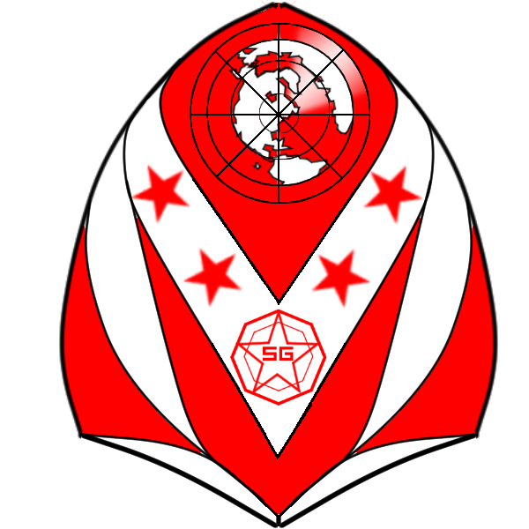

This is a mobile app which will be catered to the general public who enjoy travelling to countries and collecting souvenirs. We strive to achieve first and ­­­­­foremost, a fruitful holiday and convenience, meshed with entertainment right around the corner.

**Target audience**

The target audience for this app is tourists and people traveling to Singapore in general. However, since the app will be on the mobile platform, it will most likely be targeted at people who are at the basic level in terms of tech savvy. Our goal is to enhance accessibility of travelling for all without compromising for aesthetics or any mundane elements involved but also adding a tad bit of flavour that most other applications have not been able to provide. We intend to add small little twists to freshen up the experience and draw curiosity with regards to culture while involving as many as possible.

**Competitor analysis**

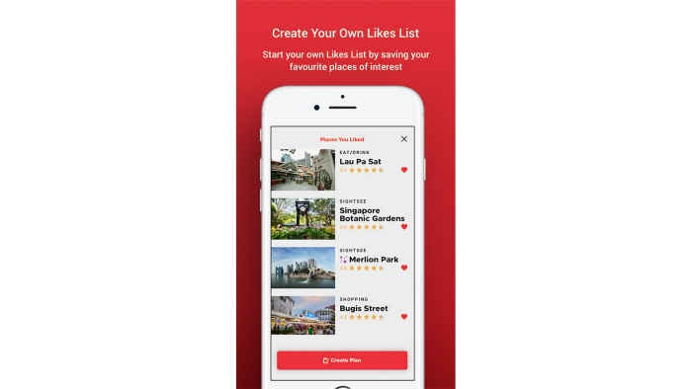The Singapore Travel Guide App is an app designed to assist tourists traveling in Singapore. The app features maps that display places of interest near the user’s location. Additionally, there is a socializing feature that allows users to find other people with similar interests.

The app also features the ability to chart a route between destinations of interest, allowing users to plan their destinations and travel plans.

Another feature the app has is an augmented reality experience which allows users to see AR elements at certain tourist destinations like Gardens by the Bay and Merlion Park. This feature teaches people more about the destination’s origins as well.

**Proposed features**

Our app will behave like any other travel app. It can help locate destinations of interest such as shops and ongoing events during the period. Additionally, the application has a “collection” feature that creates proactivity and introduces new ideas towards tourism. We intend to use QR codes to present the idea of a treasure hunt that encourages an exploration theme. The collecting feature aims to add the fun factor and build upon a strong sense of satisfaction upon succeeding.

Another feature is the ability to plan routes between destinations within a country in advance. This brings about convenience and raises awareness with regards to the landmarks of the region. We suggest a free and easy form of route such that it does not limit the users to a controlled schedule that’s similar to an itinerary. By listing out the optimized time of the day to approach the respective landmarks, it keeps the experience open-minded while still tethering to the core idea of recommending landmarks. We also make use of google maps to give a clearer idea as to the distance travelled to arrive at each location. It is ensured that the locations picked are of reasonable travel distances.

**Application designs**

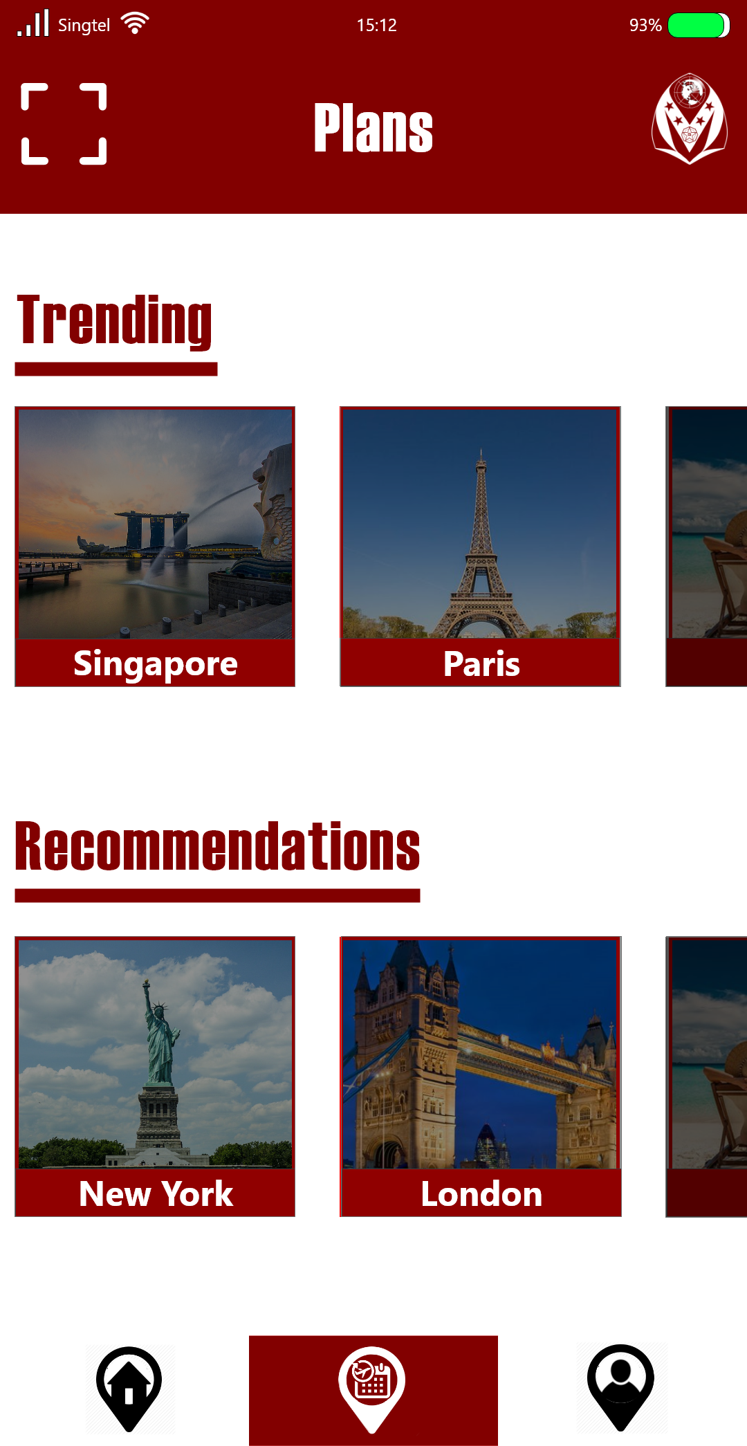 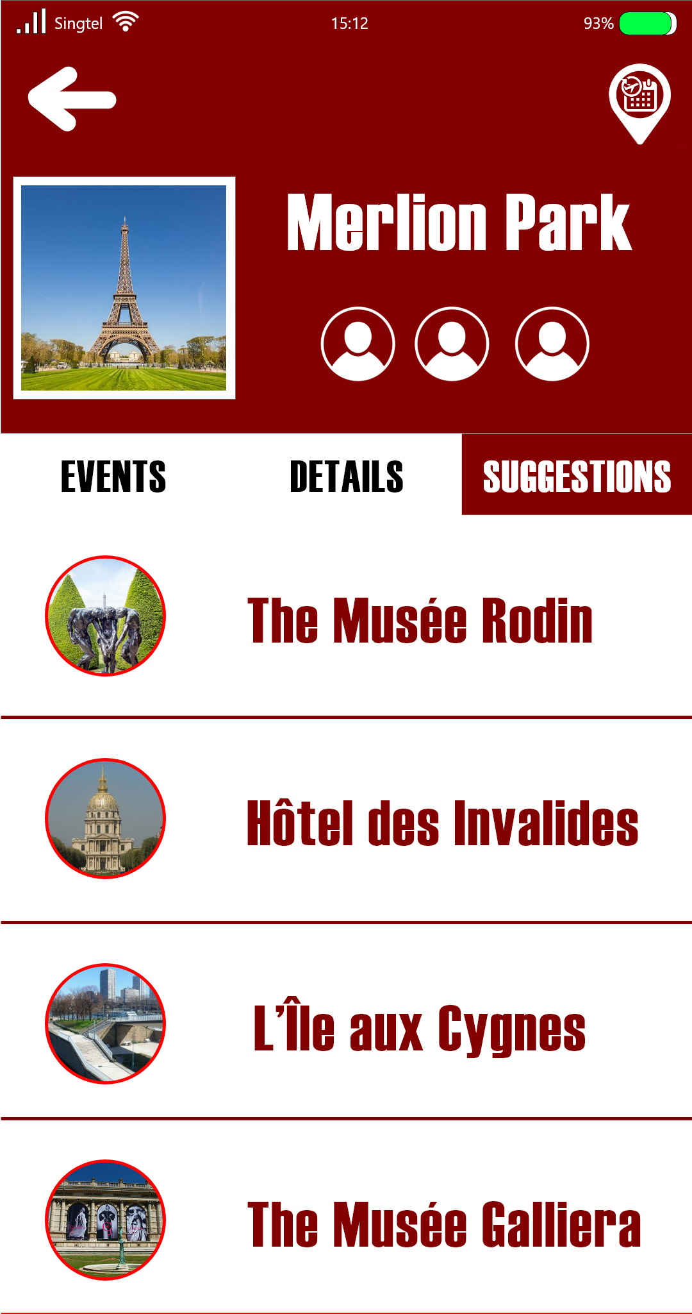

In terms of design, we’re striving for a casual yet modern look that does not deviate too far from industry standards with the key idea of accessibility in mind. It’s a simple and intuitive layout that generates optimal navigation for both the tech-savvy and the less tech savvy users. Minimalism, in this case, shines with a broader target audience being tourists and the general public as the wider picture.

**Application designs**

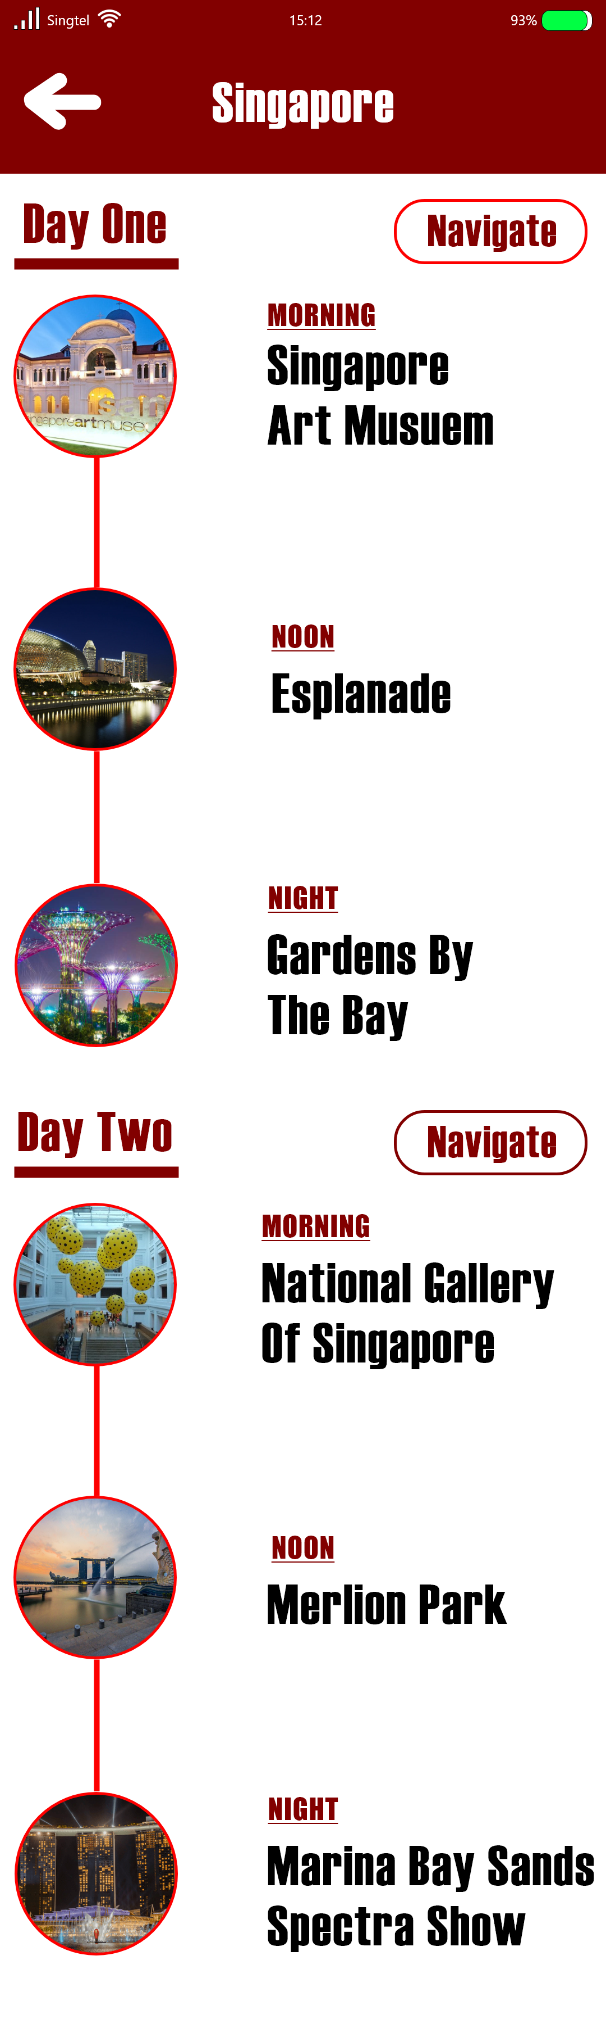 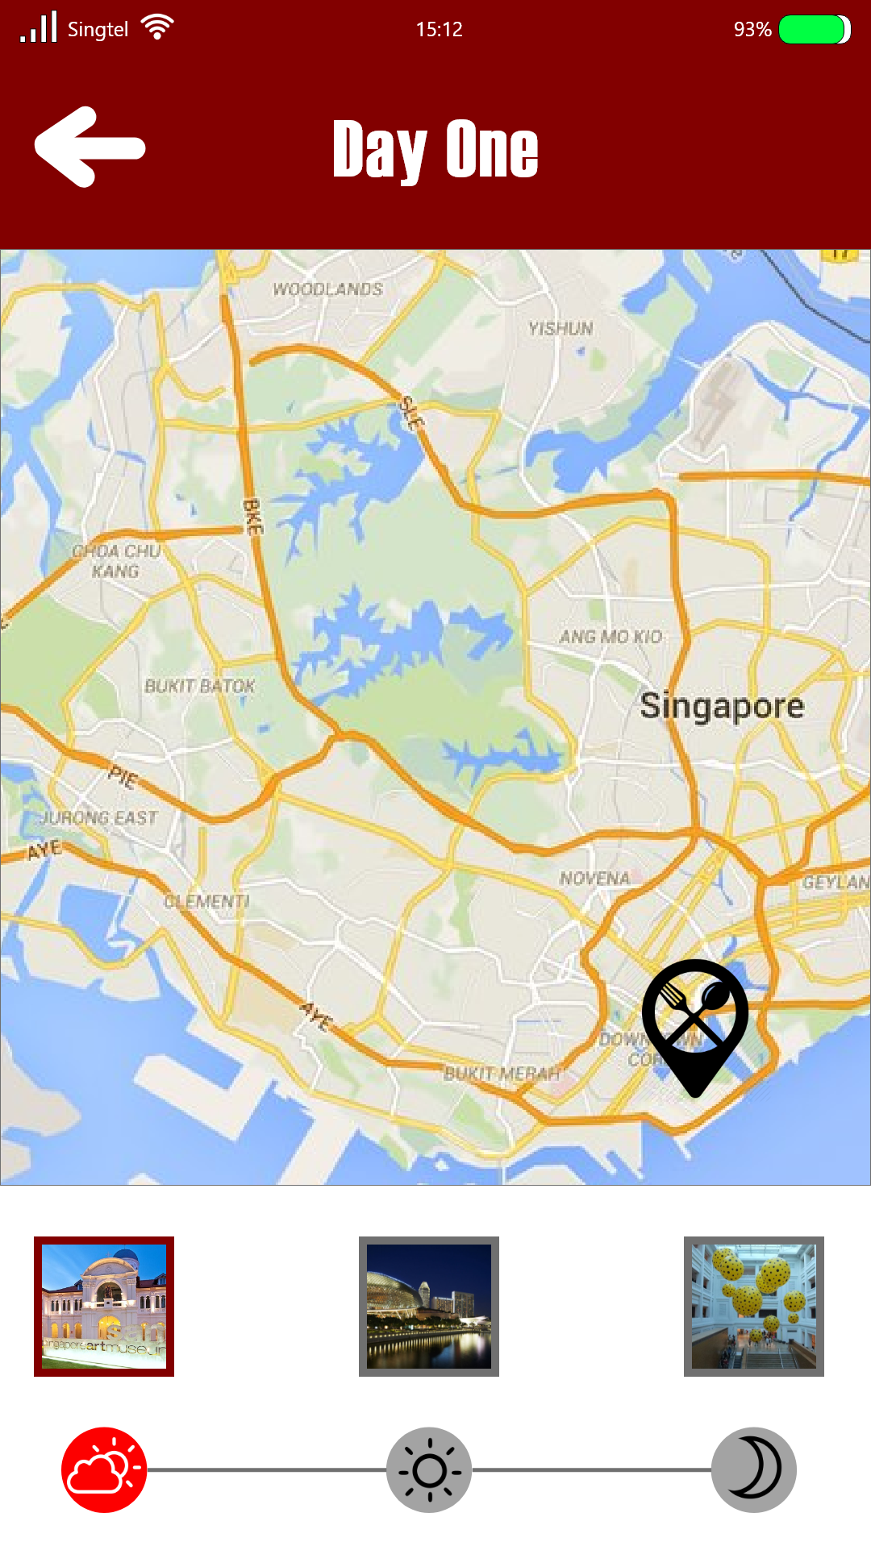

The intent to integrate a map for our functions is essential This page is intended to not only give a simple idea as to how we deal with trip planning and management but also to link multiple sources of information. So for example, in the scenario that the user might lack the knowledge regarding these locations stated in the plan, clicking on the image would bring them to the following page as shown and deliver more information regarding the landmark.

The page that enlists of details is also linked to the page with the plans should a user want to explore further with regards to our given plans. It is tagged with a clear sub-navigation bar design that holds various forms of essential information regarding the location.



In terms of color scheme, we’re looking at a deep red-brown paired with white. Color psychology plays a role in the choice using this color palette. Red is a strong representation of importance while mixing it with brown dulls the glare. This brown represents reliability and gives a sense of security. White is a common choice of color for applications that strive for simplicity and serves as the perfect contrast to the text color of black and brown-red. The combination of these colors is intended to give an idea of trust and hopefully strengthens that relationship between the user experience and the application.

**Collateral designs**

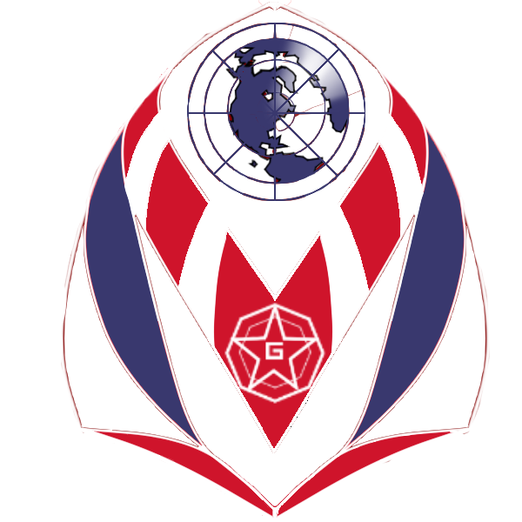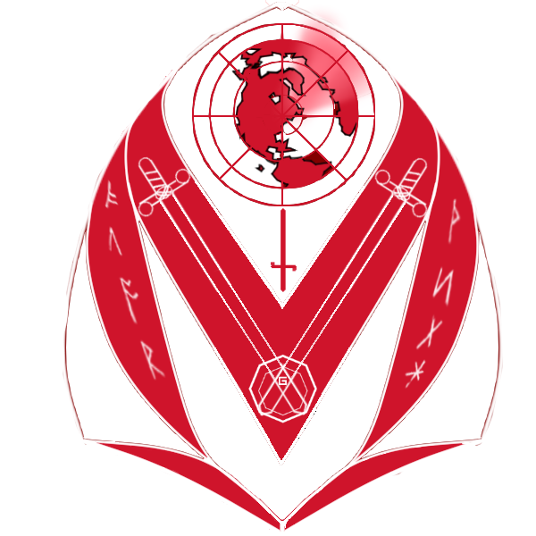

These collaterals are designated for the fun collectors function and are intended to bring a necessary twist to draw appeal for the application. The idea is to invent a badge-like system that will come off as optional yet satisfying in the approach. The badges resemble that of crests which carry significant elements from various countries, starring stars, symbols and layout. These decorative aspects create a unique identity for each crest and differentiates them accordingly. For example, the first red crest from the left can be easily identified as one that represents England. Notably the swords especially the red one in the centre that is a recognized national symbol.

The second crest has a more sporty and vibrant design. This design becomes more distinctive in its choice of rich colours instead of relying on the common pair with white. It’s supposed to represent France which not only ties in to the national colors of their flag but that sporty look also contributes to notable events, such as France winning the World Cup.

The 3rd crest is a direct representation of Singapore. Though the colors aren’t matching for a flag, it meets that of the application’s color scheme and still intends to drive that identity with notably the 5 stars. The design is a little more plain considering that it is the first original design of a badge.

The final design goes to the United States. The color scheme intends to match that of their flag and the unique point is its layout that is significantly different. The idea behind this layout is to showcase how they connect with the world openly and brings about a substantial variety when it comes to tourism.

**Collateral designs**

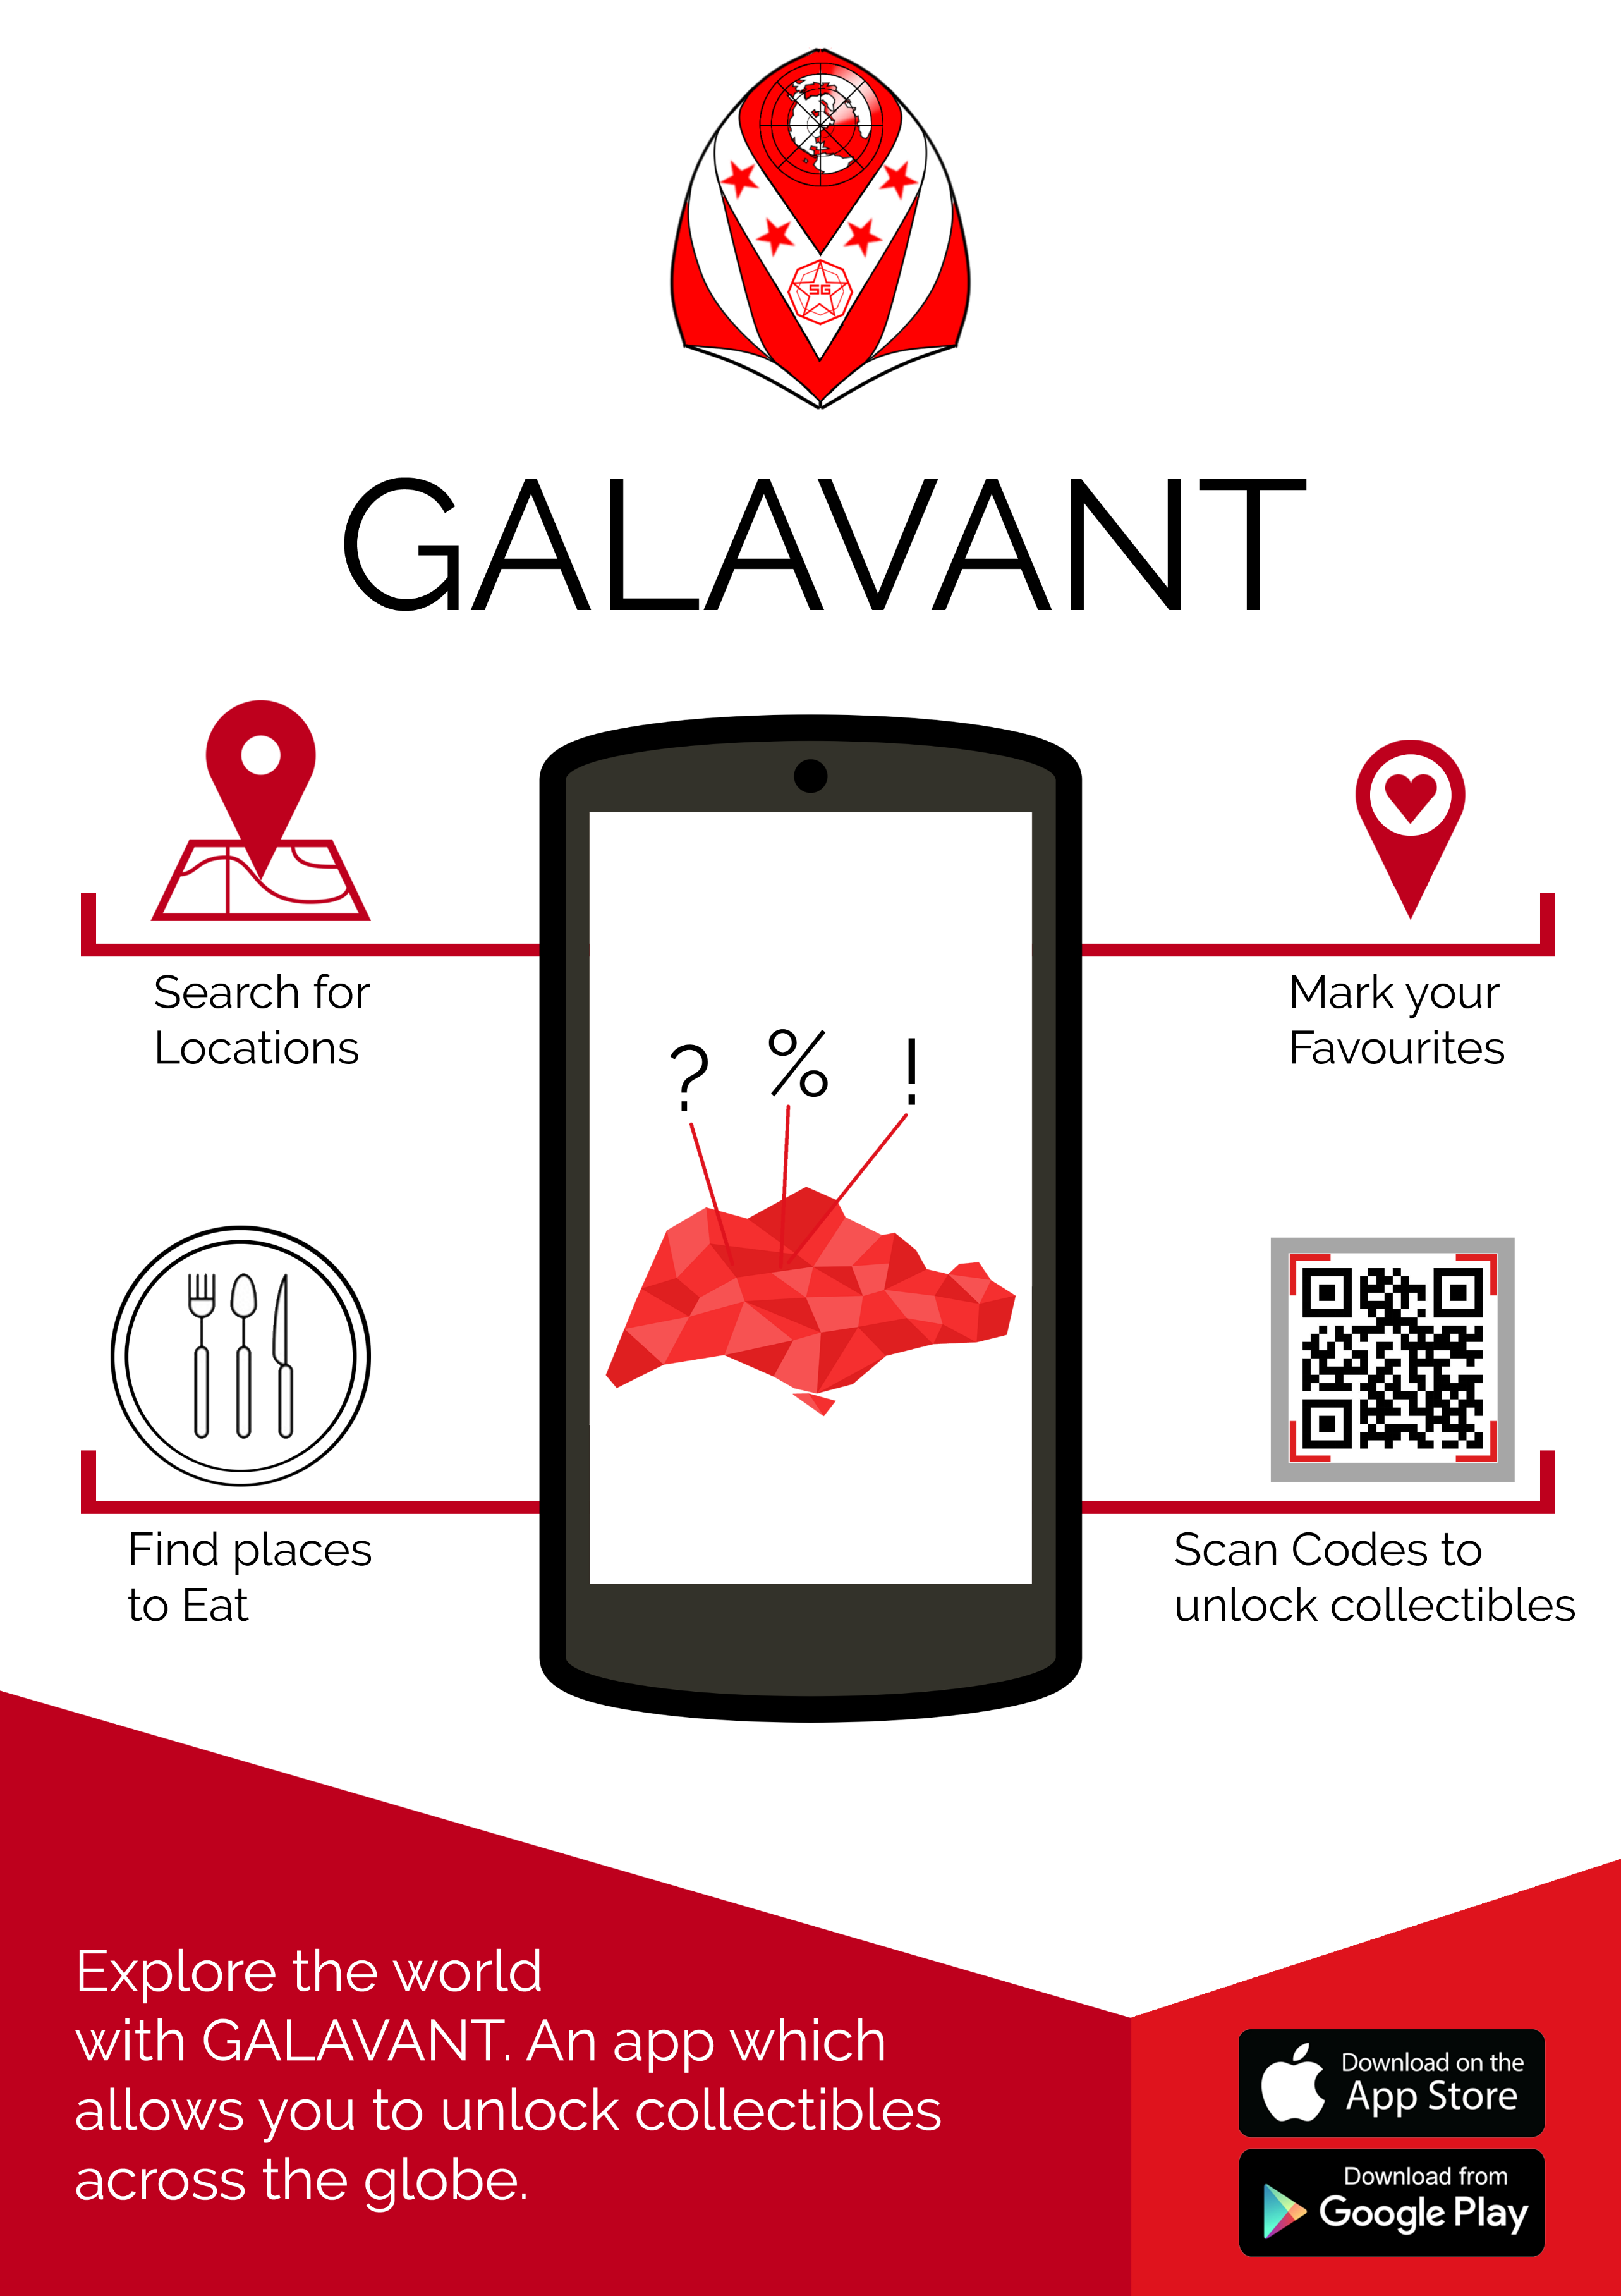

Out of the many ideas we intended for a poster such as mascots, we decided to tone it down to a simple and informative poster that targets Singapore for now. We pinpointed the core functions of our application while creating a notable identity that this is a Singapore-centric application; ceating a low-poly visual to match our 3D model assets that we intend to present in our application’s fun factor of collecting models